**Table of Contents**

**EXECUTIVE SUMMARY**4

**INTRODUCTION**4

**PROJECT GOALS AND OBJECTIVES** 5

Problem Statement & Goals 5

Objectives 5

Constraints of the Project 5

Project Objectives 6

**DESIGN DESCRIPTION**6

Overall System Description 6

Technical Specifications of Subsystems 7

Grab, Raise & Drop Subsystem 7

Magnetic Grabber 7

RAM Screw 8

RAM Slider 9

Mobility Subsystem 10

Movement of the Robot 10

Feedback 11

Vision and Decision Subsystem 11

Electronic Subsystem 16

Components 16

Microcontroller 16

Sensors 16

Motors 18

Motor Driver 18

Power Supply 18

Power Management Analysis 19

**TEST PROCEDURES AND RESULTS**20

**MODIFICATIONS TO CRITICAL DESIGN REVIEW REPORT**24

Image Processing 24

Grab, Raise & Drop Subsystem 24

Sensors 25

**COMPATIBILITY OF SUBSYSTEMS**25

**REQUIREMENT ANALYSIS**27

Obtained Performance 27

PROJECT MANAGEMENT 28

Team Organization 28

Budget and Deliverables 29

**CONCLUSION**30

**REFERENCES**31

**APPENDIX A : USER MANUAL**31

# **EXECUTIVE SUMMARY**

As the innovation on technology grows further, robots are coming into people’s daily lives. Today, people are already working on developing robots which will ease the burden on the humans. One of the best ways to blend robots to daily life is to imitate them in sports area where most of the physical functions of a human is used. For this reason, RAM aims to create a robot that can play basketball.

As RAM Company a robot that take part in a basketball shoot-out against another one is designed and created by ourselves. The robot will win the match if it scores three balls into the basket before the opponent. Robot will have the ability to detect the balls, pick up them from any point on the court, decide where to place (into the basket) and complete the move by putting at least three balls into the basket. To detect the balls, pixel wise image processing will be conducted by camera (pi cam), and the distance will be measured by sharp infrared sensors. Sensors and camera is controlled by Raspberry Pi and Arduino Mega. A mechanical arm will be assembled in front of the robot for proper picking up and dropping actions. For a fast, agile robot, DC geared motors will be used and be controlled by Arduino.

RAM has everything needed for such robotic task. Our team consists of 5 skilled electrical and electronics engineering students who will be graduated from Middle East Technical University which is one of the best technical universities of Turkey. Members have the skills in image processing applications, power electronics, power systems, programming languages (Python, C++), mechanical design, and project management collectively.

The robot will be basically formed of camera and sensors to recognize the environment; 2 wheels driven by DC motors to move and 1 ball caster; control cards such as Arduino UNO, Raspberry Pi (as brain of the robot); power supplies, and additional mechanical elements such as body frame.

The project is estimated to be completed within 7 months and an early cost analysis yields about 200 USD total project cost.

# **INTRODUCTION**

Basketball is a sport that requires mental ability as well as physical ability. Players should consider different strategies to win the game and eliminate the opponent. This strategy may include speed, precision, energy efficiency and decision making.

RAM Company is interested in creating robots that can take part in a basketball shoot out due to its challenging aspects and integrity of daily life. RAM believes merging robotics technology and daily life is a huge necessity in order to get people familiar with technology and robotics. Therefore; as RAM Company, we have agreed on designing a robot that simulates a basketball shoot out and competes with another robot.

For the project, robot should score more points than the opponent. Shootout will be held on a field that has two sides. Different from the real basketball, there will be one basket only and it will be placed at the middle of the field. Both parties will try to score at the same basket, so this will add extra challenge to it. Each side will include a base line and the balls will be placed behind the baseline. So, robots need to search for the ball first, then grab it and shoot it into the basket. The team that reaches 3 scores will be the winner, so aim is to score 3 times and to be faster than the opponent.

The project is divided into 4 subsystems which are Grab, Raise & Drop, Mobility, Vision & Decision and Electronics. We have finished the design of the Grab, Raise & Drop Mechanism and made the necessary tests. The results of the tests are explained in detail in this report. For mobility of the robot, several features such as motor types, place of the wheels and feedback mechanism are decided by considering alternatives and their advantages and disadvantages. Selection process of these features will be explained in detail in this report. For Vision and Decision subsystem, Image processing is done and results and tests about image processing will be explained in this report. In the electronics systems, equipment selection process is explained.

# **PROJECT GOALS AND OBJECTIVES**

## Problem Statement & Goals

In this project our aim is to design an autonomous robot which is able to detect the balls and grab and lift them, carry them to the basket and shoot the ball to the basket. When the robot finishes the first cycle, it will start over again until the basket becomes full or there are not any balls left.

**Project Goals**

The aim of this project is to design a robot which takes part in a basketball shoot against an opponent.

● The robot should play in a decision mechanism.

● The robot should detect game field, in order to detect its basket and balls, not opponent’s balls and basket.

● The robot should be able to pick up, carry and place balls in the basket.

● After a succesful score, the robot should search another ball.

● The full cycle is going to continue until any balls left in the field.

## Objectives

### 3.2.1 Constraints of the Project

● The robot must be able to fit inside an upright cylinder of 30 cm in diameter.

● The field must be of width 70cm.

● The robot should be operating in all lighting conditions.

● The robot should never enter into opponent’s field.

● The robot should not be more expensive than $200.

● The robot should be completed by May, 2018.

### 3.2.2 Project Objectives

● The robot should be completed in May 2018.

● Robot should be able to detect the balls, basket and game field by using image processing method.

● Robot should be able to detect the balls in the range of 3 centimeters with sensors

● Robot should be able to distinguish opponent’s and our balls by the aid of image processing.

● Robot should be able select a ball to go towards within 10 seconds.

● The robot should be able to pick up, carry and place balls in the basket within 1 minute.

**3.2.3 Company Objectives**

● Improving our technical knowledge and put it into practice.

● Improving the skills for taking responsibility as an individual and working as a team.

● Producing a robot satisfying all requirements and available to be upgraded according to different circumstances.

● Being awarded due to the robot that will be produced.

● Experiencing how to manage a long-term project and improving the skills of taking responsibility in a team.

# **DESIGN DESCRIPTION**

## Overall System Description

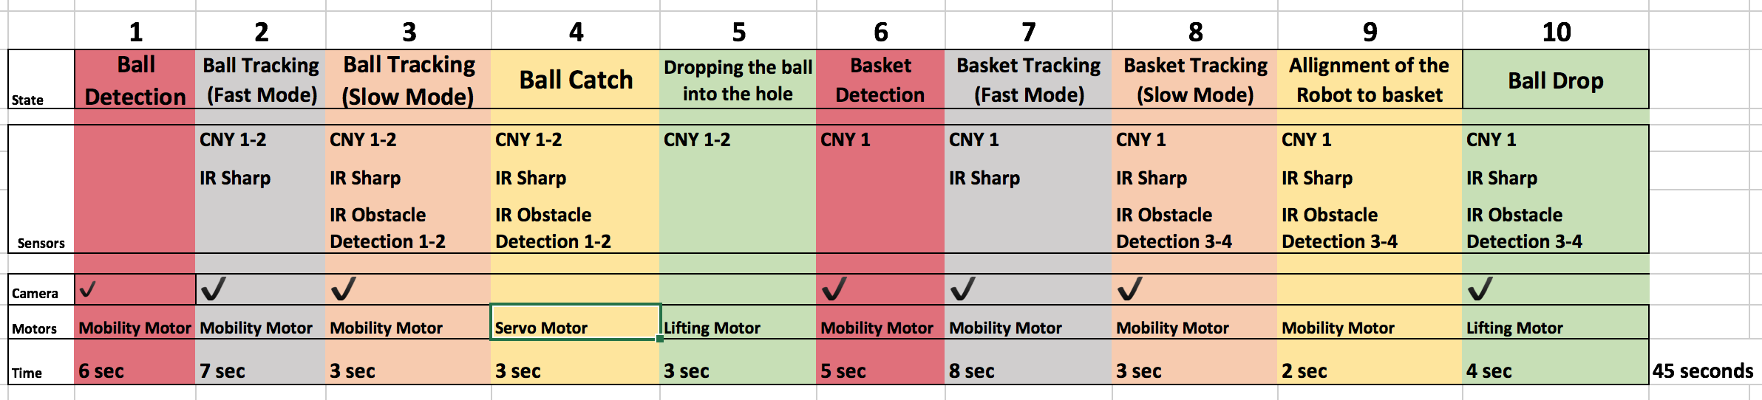

## Technical Specifications of Subsystems

### Grab, Raise & Drop Subsystem

This subsystem is responsible for grabbing the ball, raising the ball to the basket level and drop the ball into the basket. Ball is a table tennis ball with a weight of 3-4 grams, which is negligible from the operational aspect of the project.

#### 4.2.1.1 Magnetic Grabber

Magnetic grabber designed as a linear actuator and neodymium magnets glued to its tip. When the robots come close enough to the ball. Actuator takes signal from front sensors and stick part of the grabber goes outside the robot, into the ball. When it goes close enough, neodymium magnets attract the ball. Then actuator pull the ball back into the robot. Ball is mechanically forced to drop into the screw base and actuator goes completely OFF position. Linear actuator model is shown below in figure 4.3

Linear actuator system has a servo motor which works under constant voltage. It changes position according to PWM input. Since speed and voltage values are constant for our servo motor, our test results for operation speed is constant and measured as 1 seconds for pull out, 1 seconds standby and 1 seconds for pull in. 1 second standby time is decided by the team, so we guarantee that ball has enough time to be attracted. RAM Grabber “IN” and “OUT” positions are shown in figure 4.2.

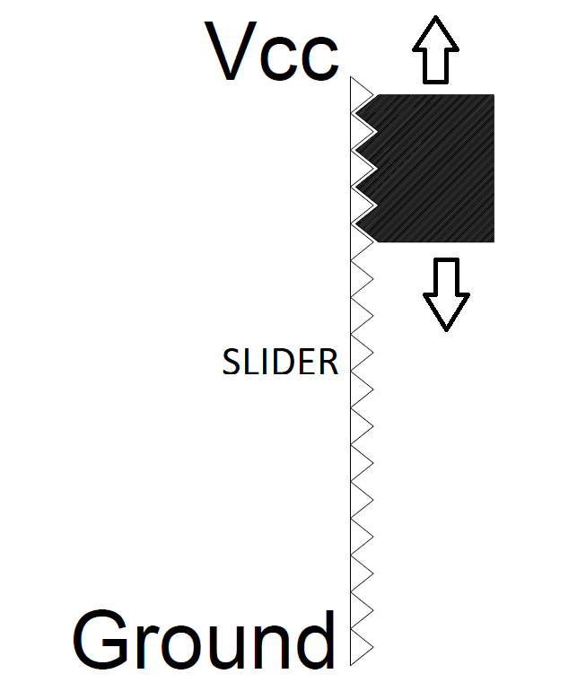

***Figure 4.1 Linear actuator representation***

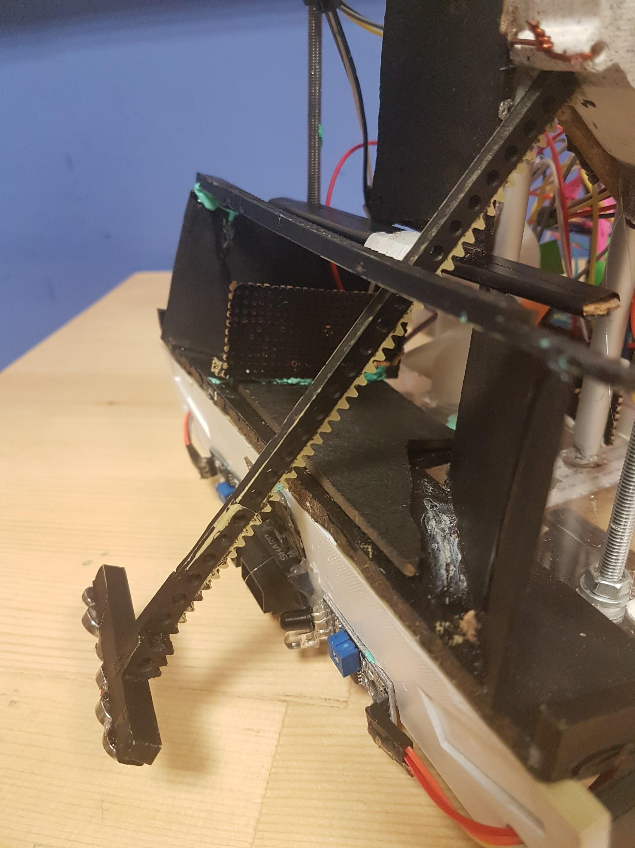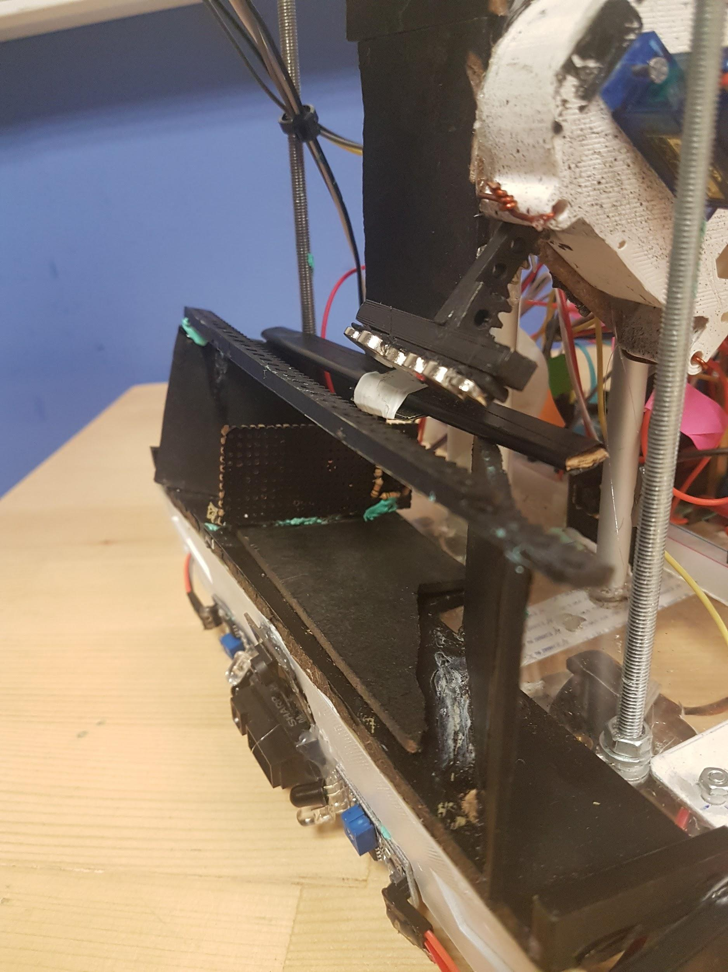

***Figure 4.2 Magnetic Grabber “OUT” position (left) and “IN” position (right)***

#### 4.2.1.2 RAM Screw

RAM screw is an “Archimedes Screw” modified for the operation of the robot. It has a DC motor connected to it so that it rotates in the clockwise direction. After the ball is pulled into the robot via ram grabber, sensors check for the position of the ball. If the ball is not placed properly into the hole due to positioning of the RAM Screw, screw is rotated slowly until the ball is placed down to the hole properly. Another sensor detects proper placement and stops the screw when the ball is placed. Robot starts seeking for the basket after the proper placement of the ball.

When the robot successfully aligns itself with the basket, such that it is ready to shoot, DC motor starts rotating the RAM Screw. Ball is raised to the RAM Slider system and mechanically forced to drop and slide down on the RAM Slider. Different DC voltages and lifting time values are tested and measured. Test results are shown under title “Test Procedures and Results”. Photo of the RAM Screw is shown in figure 4.3 including the DC motor for rotation.

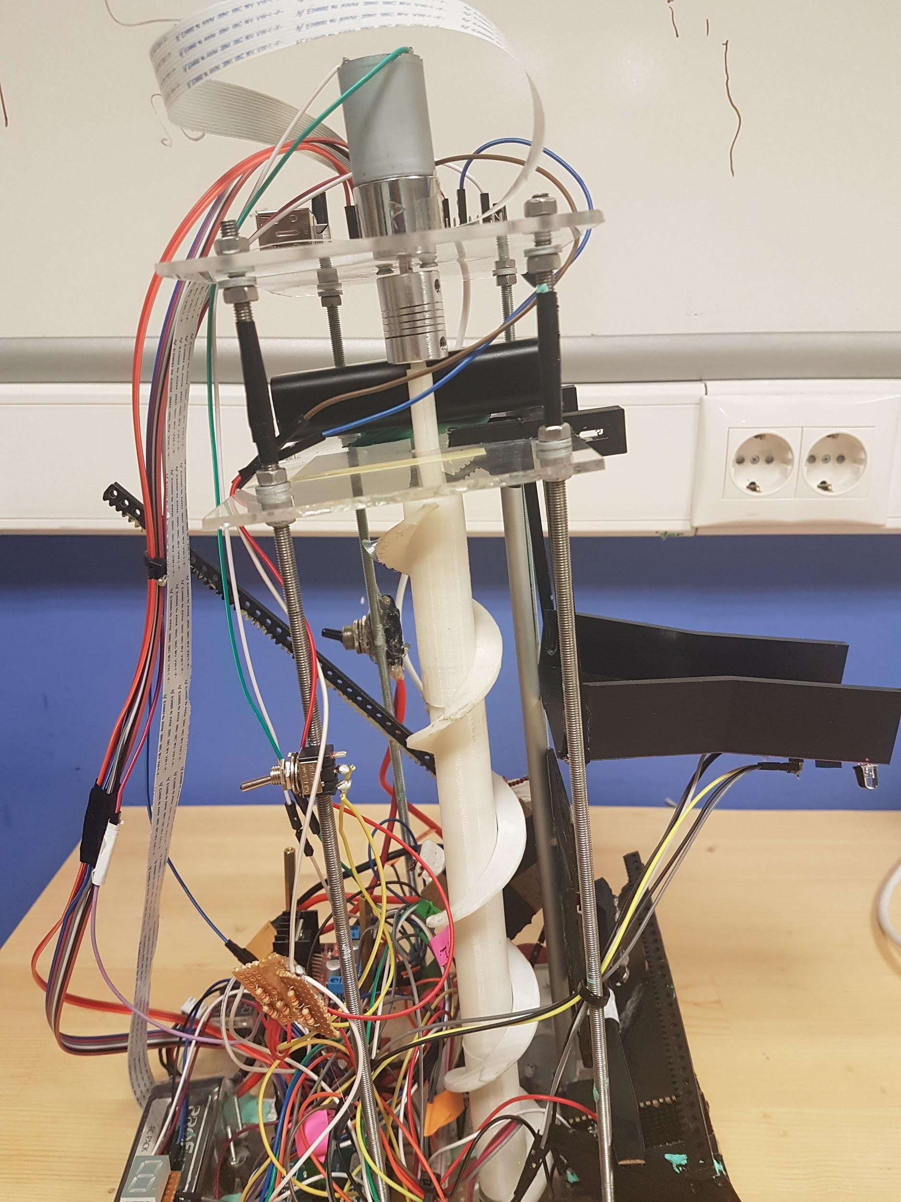

***Figure 4.3: RAM Screw***

#### 4.2.1.3 RAM Slider

RAM Slider is a mechanical system especially designed to ensure that any shoot after proper alignment of the robot with the basket is resulted in a score with a success rate of 100%. It is designed in 3D CAD software and completely 3D printed, including the attachment arms.

It has a slope of 5 degrees so that the ball can slide down slowly for safe shooting. It is attached to the robot with attachment arms. Tip of the slide is 21 cm above the ground and 2 infrared sensors attached at the bottom of it for basket detection and alignment. Photo of the RAM Slider is shown in figure 4.4.

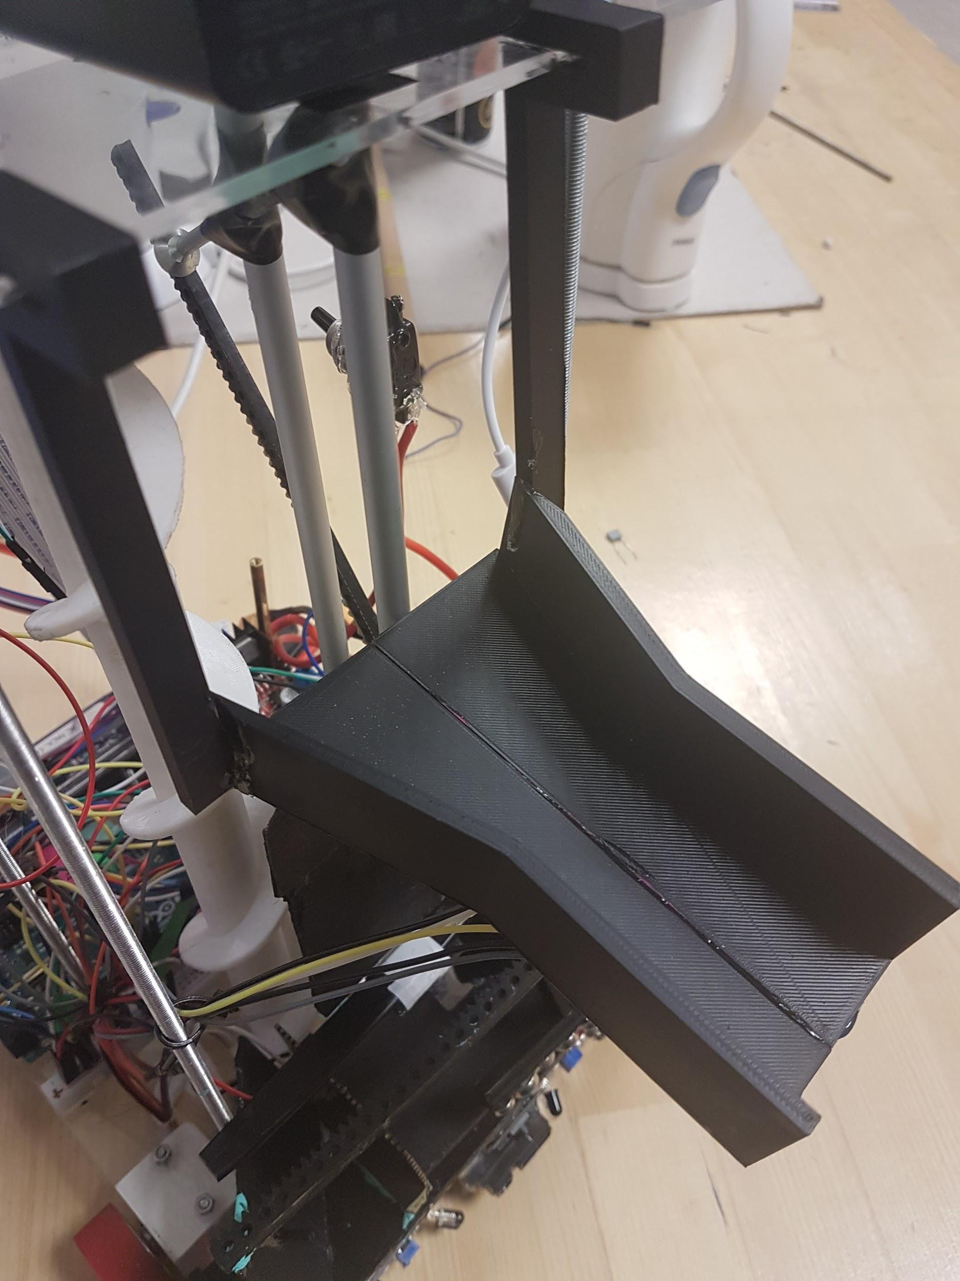

***Figure 4.4: RAM Slider***

### Mobility Subsystem

#### 4.2.2.1 Movement of the Robot

In our robot we used two wheels connected to the DC Motors located at the front side of the robot and a caster wheel located at the back. Since most of the weight of the robot is located at the front, this design is more suitable to maintain the balance of the robot. Motor-wheel places are shown in figure 4.5

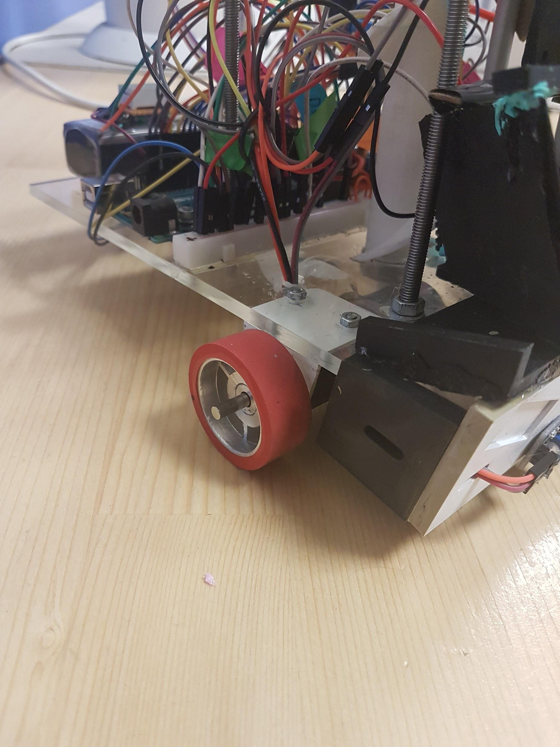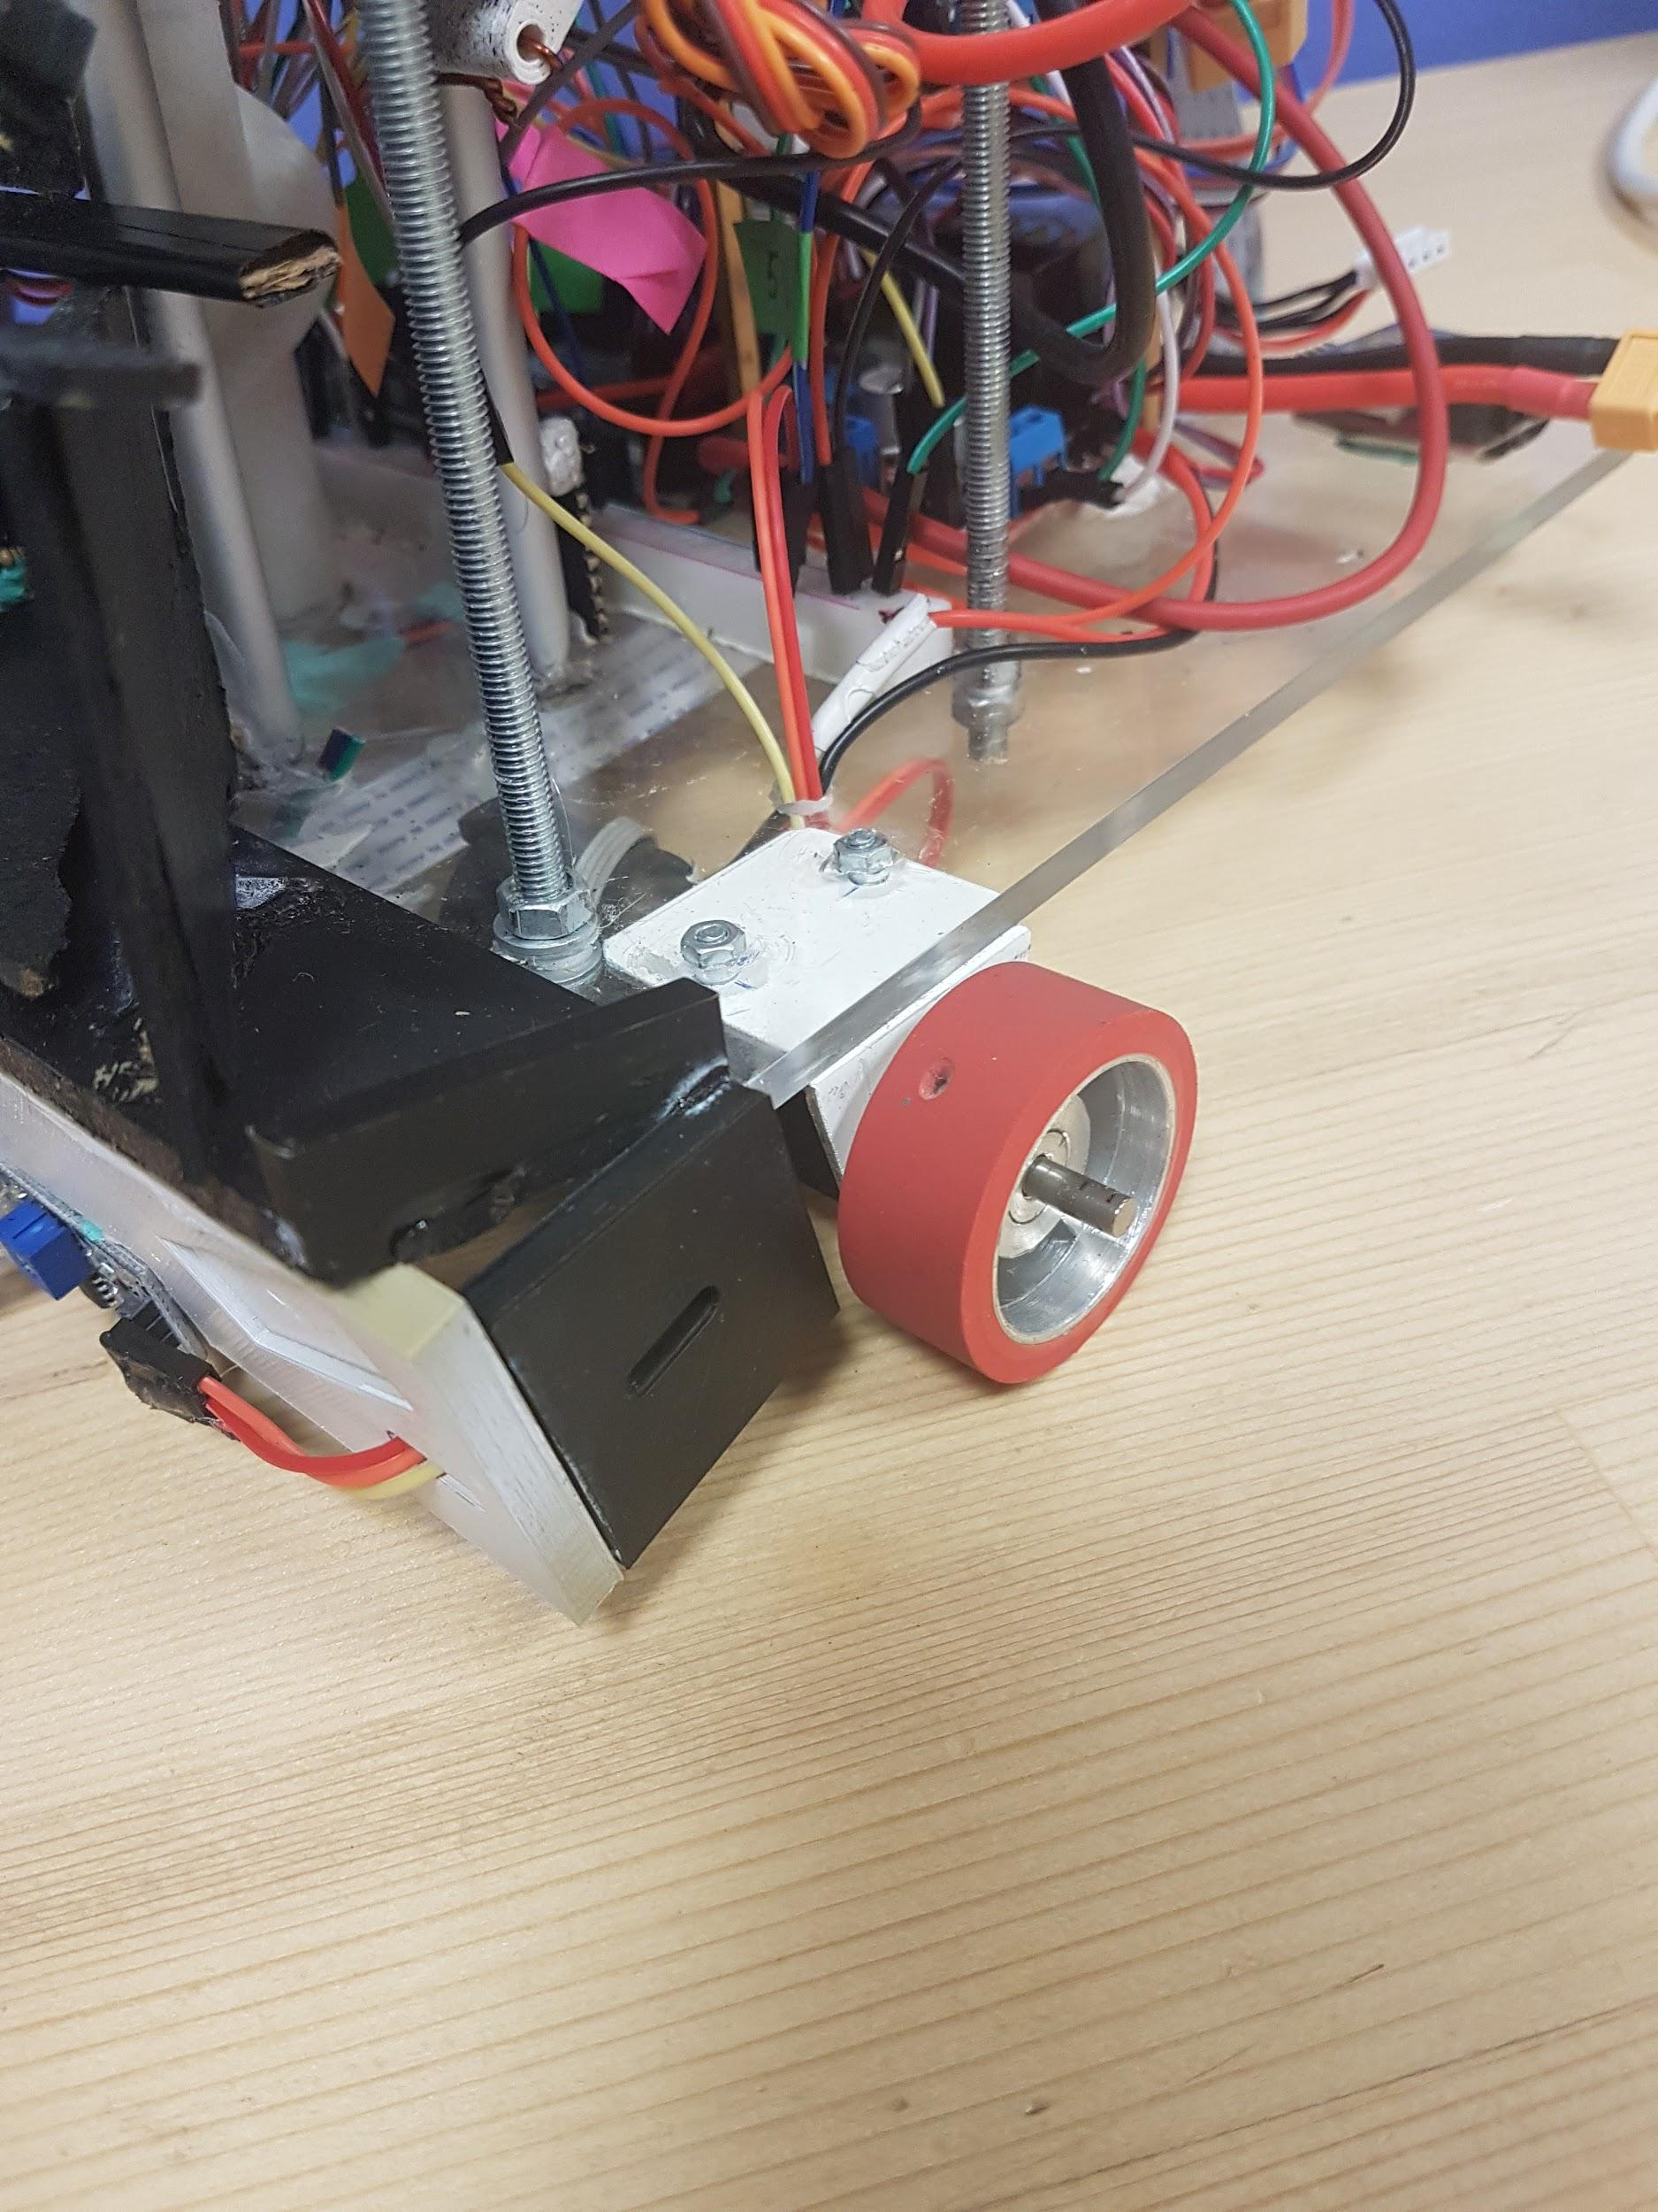

***Figure 4.5: Wheel locations at the front of the robot.***

#### 4.2.2.2 Feedback

In the feedback loop the objective is the keep the target in the middle of the image. Error function is the difference between the target’s coordinate and the middle “x” coordinate (200). In the feedback loop we used P controller.

During the full cycle the robot completes 10 states and returns the first state. After detecting the target (ball or basket) robot continuously getting horizontal coordinates and interprets the coordinate data to find its way. While the robot is approaching the target, sensor data is used to adjust the speed or to stop. These states can be observed below in Figure 4.7



***Figure 4.6: Full cycle state diagram***

Full cycle takes approximately 45 seconds to complete, but this number can decrease or increase depending on the location of the balls and robot.

### Vision and Decision Subsystem

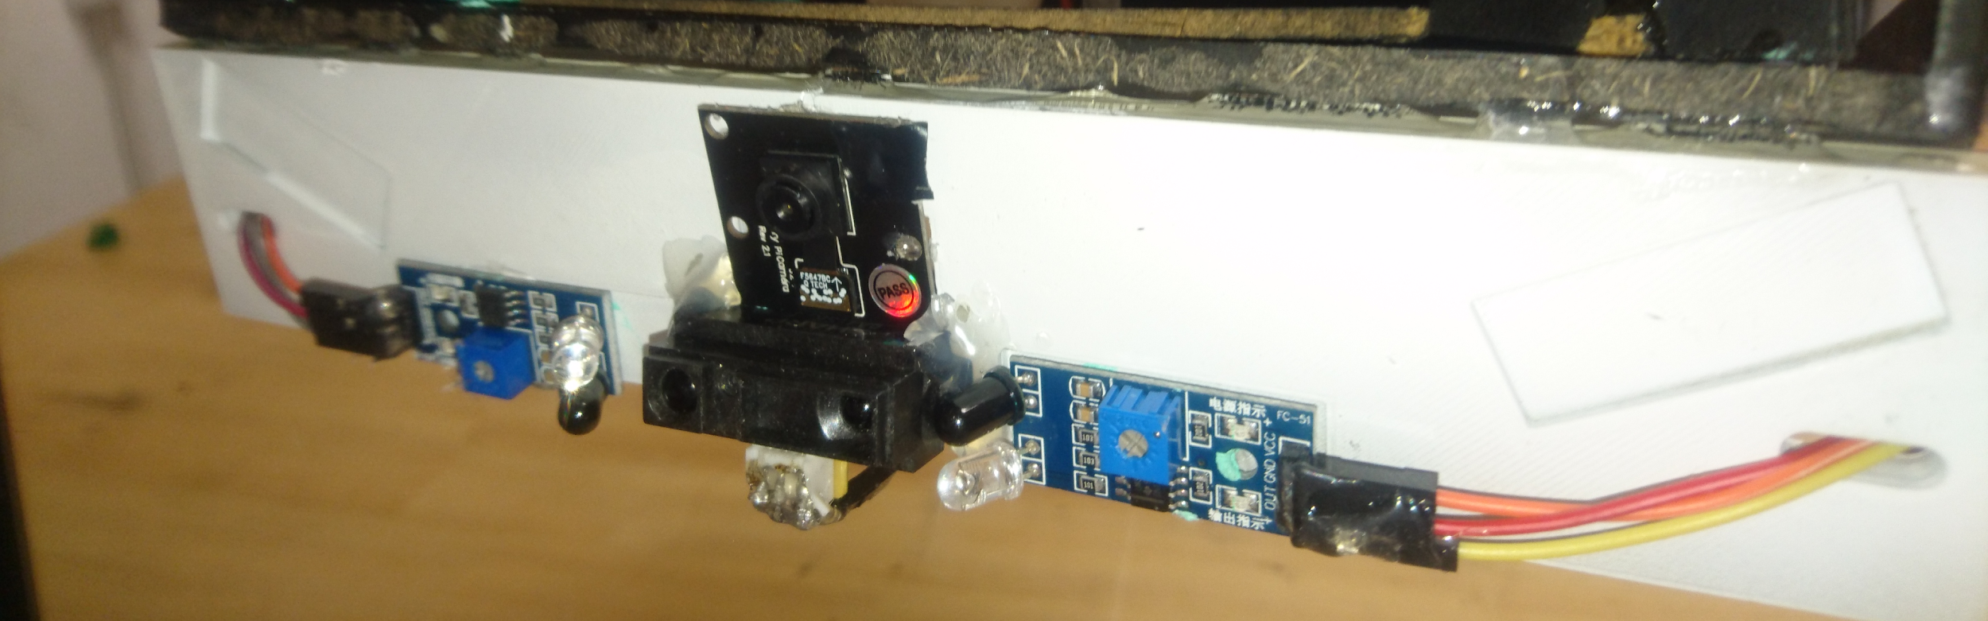

***Figure 4.7: Pi-cam on the robot***

One of the main modules of the robot is the vision module. It requires a camera and a platform for the computations (Raspberry Pi) as hardware. This module simply detects any object, specifically colored balls and the basket on the playground, and sends the position data to Arduino to drive motors. The module includes three subsystems. The structure of the module is shown by the block diagram shown in Figure 4.8

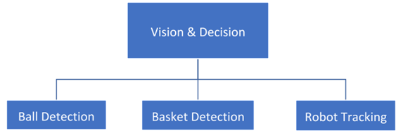

***Figure 4.8: Vision & Decision unit***

**Ball Detection**

In this sub module, the frame taken from the pi camera is processed so that the ball with a specific color on the playground can be detected. The overall image process algorithm can be seen from the figure 4.10. The process of this module is done on Raspberry pi openCV python programming language environment. The procedure in this mechanism simply includes converting the image to HSV color space, and constructing a mask to the image for desired color (red, blue, green), then detection of non-circular objects on image by finding their contours and eliminating them, and finally computing the center of the largest contour and sending the data via serial GPIO communication. The output image of the ball detection unit is shown in the figure 4.9.

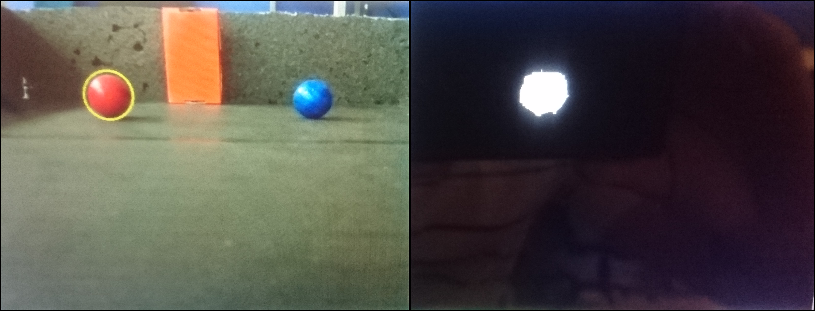

***Figure 4.9: Results of the ball detection unit***

Masking the color is simply reached by filtering the image according to the predetermined HSV maximum and minimum thresholds. These threshold values are determined according to the light of the medium that robot performs. Secondly, these masked images are inputted to open CV’s contour finding and shape detection functions as you can see in the figure 4.9, and the circles with a specific color is detected. Then, center of the detected largest circle is computed by openCV moments function and this data sent to the Arduino via serial GPIO to drive the motors based on the pixel values of the centroid of the ball. Another switch is mounted to the robot to change the specific color to be detected from red to blue.

,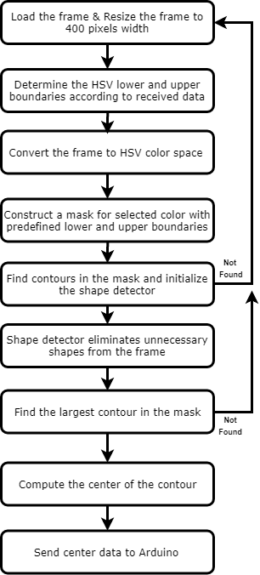

***Figure 4.10: Image process algorithm***

Decision of the movement is based on the pixel number of the centroid. Since the pixel width is 400 and the centroid of the ball is located to the pixel number bigger than 200th pixel on x-axis then the robot will move right, otherwise will move left if the pixel number is less than 200th pixel. The robot also will move forward or stop according to the mentioned algorithm and the data inputted from the Sharp IR sensor.

**Basket Detection**

Basket detection algorithm is implemented similar to the ball detection algorithm. This time a different specific color (that is green) is detected with the same method of the previous part by changing the threshold values of the HSV color space. The change of the HSV color values are depend on a signal that changes via CNY70 sensor and comes from Arduino to Raspberry pi. If CNY70 sensor detects that the ball is picked then the same image process algorithm with the ball detection changes its HSV boundaries automatically to green color, and search for the basket. Then robot will move towards the basket, and DC motor will perform to shoot the ball with the help of the lifting mechanism. In implementation of shot phase, robot's position is controlled by the basket detection, and IR sensors.

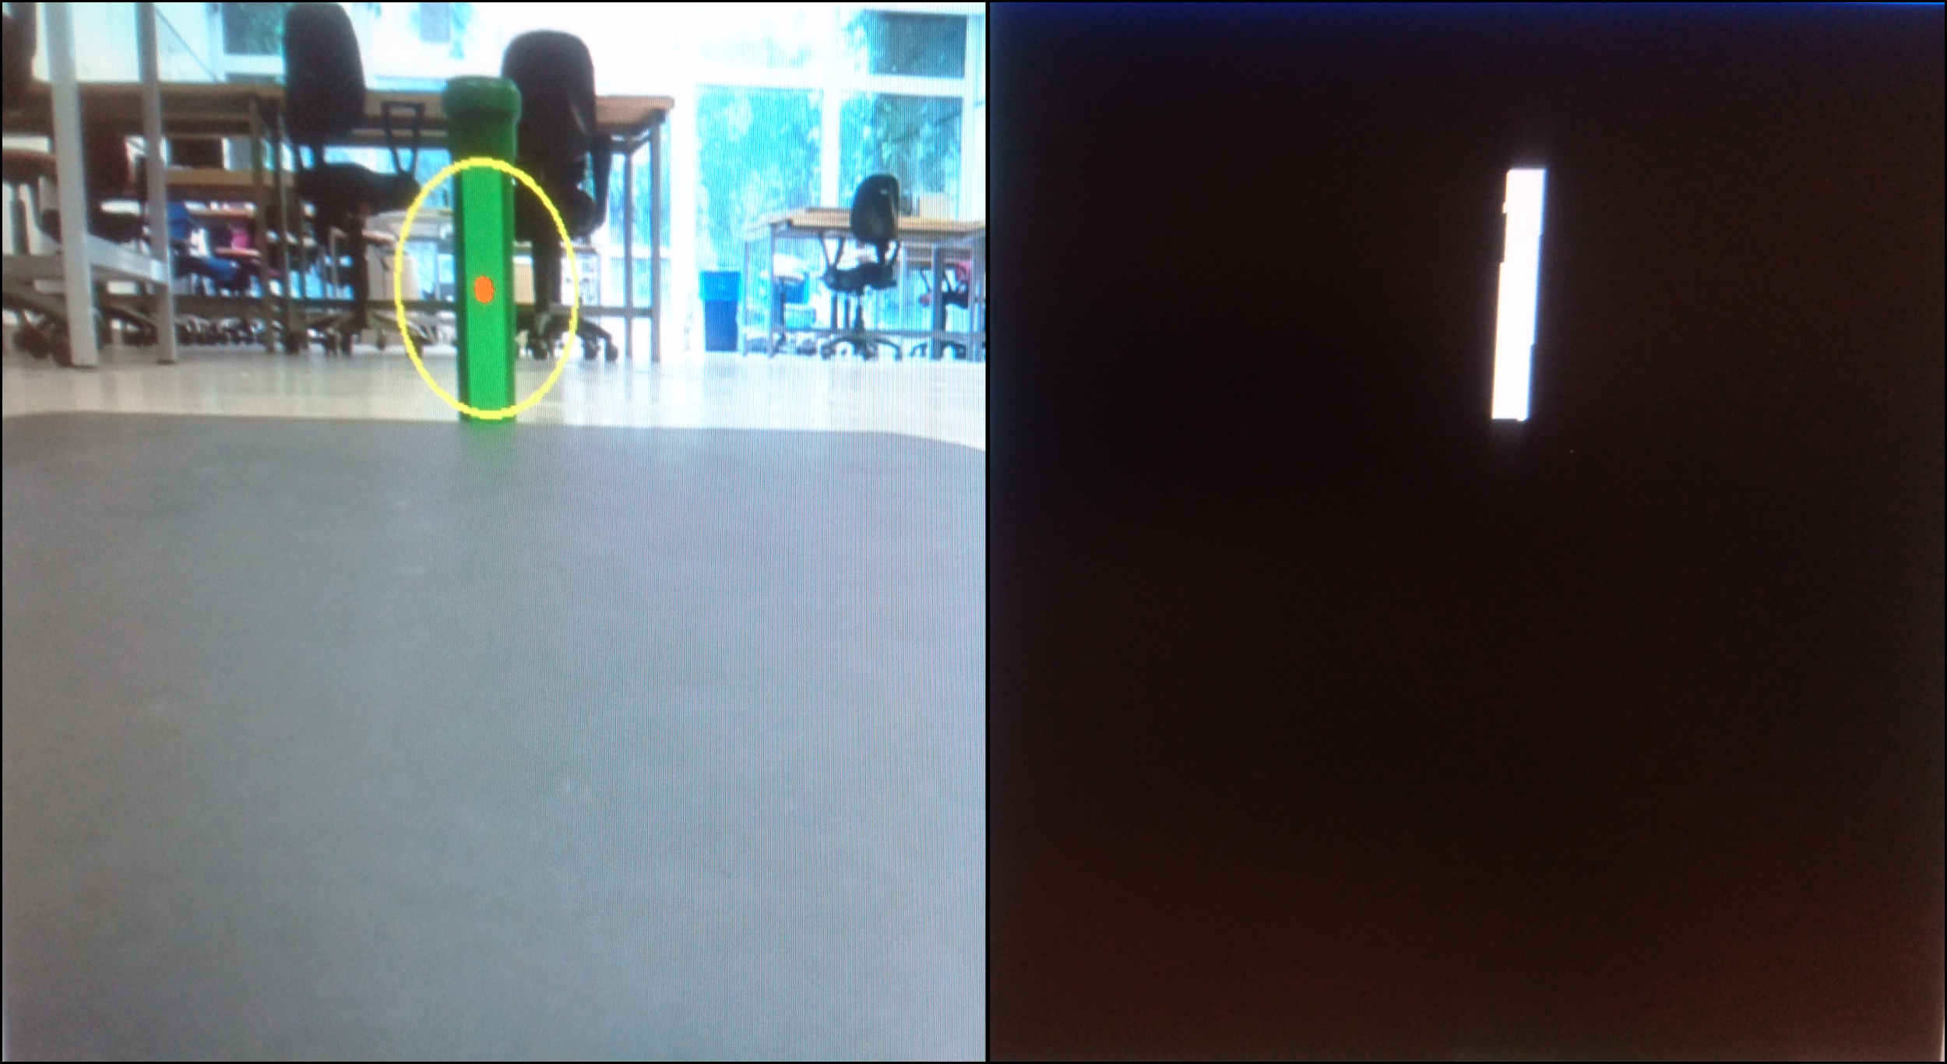

***Figure 4.11 Results of the basket detection unit***

**Robot Tracking Algorithm**

Robot tracking algorithm is the overall algorithm of the decision unit that is implemented by Arduino. It includes all the detection sub-modules of the Vision & Decision sub-system. Since the control of robot’s movement is another problem. Even if detection of balls and the basket are processed correctly, without the appropriate implementation, the probability of failure is high. Therefore, the overall software system algorithm of the detection process must be carried accurately.

A general behavior of the robot in the solution process is described by the chart, placed in the Figure 4.12. This flow chart summarizes the function of decision system.

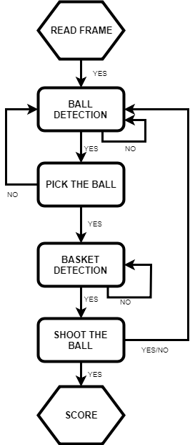

***Figure 4.12: Flow chart of the decision unit***

### Electronic Subsystem

#### Components

##### Microcontroller

Microcontrollers are the control units of the system. Arduino Mega and Raspberry Pi are selected as control units.

Raspberry Pi is responsible for the image processing as mentioned in the vision/decision section. After detecting the center coordinates of the ball, it will be delivered to Arduino by GPIO connection. Arduino will be processing data coming from Raspberry Pi and it will give the proper outputs to motors.

Furthermore, all sensor data inputs, and center of the ball data are used to straight movement toward ball by using P control technique.

##### Sensors

In the design of the robot, 1 IR Sharp (GP2Y0A41SK0F) sensor, 4 IR obstacle detector sensors (FC-51), 2 CNY70 sensors are used.

IR Sharp sensor will be responsible for the distance measurement while heading to ball/basket. Its range is between 4-30cm. According to data coming from IR Sharp sensor, robot slows down for the accurate movement at the close distance from ball/basket is obtained. Output of the IR Sharp is analog hence it is connected to analog input of the Arduino.

IR obstacle detection sensors have digital outputs such that it makes output low if any obstacle is detected within the range of the sensor. Its range is 0-10 cm. 2 of them are used in the front chassis of the robot to determine the time when ball catching mechanism should work and also robot will stop. In other words, they are responsible to detect balls when the distance of the ball to robot becomes 3 cm. Other 2 of the IR sensors are placed under the slider. Their purpose is to align the robot when robot reaches to basket. Unless 2 of them are not detecting basket at the same time, drop mechanism will not be working.

CNY70 sensors are also obstacle detection sensors but their range are 0-0.3 mm. Their aim is to understand whether ball is caught successfully or not. CNYs are placed to only possible locations that balls will drop after catching mechanism worked.

Figure 4.13 shows the robot states and which sensors are active at that state. Also Figure 4.14 show sensor placements at the front of the robot and sensor ranges.



***Figure 4.13: Sensor time table for full cycle operation.***

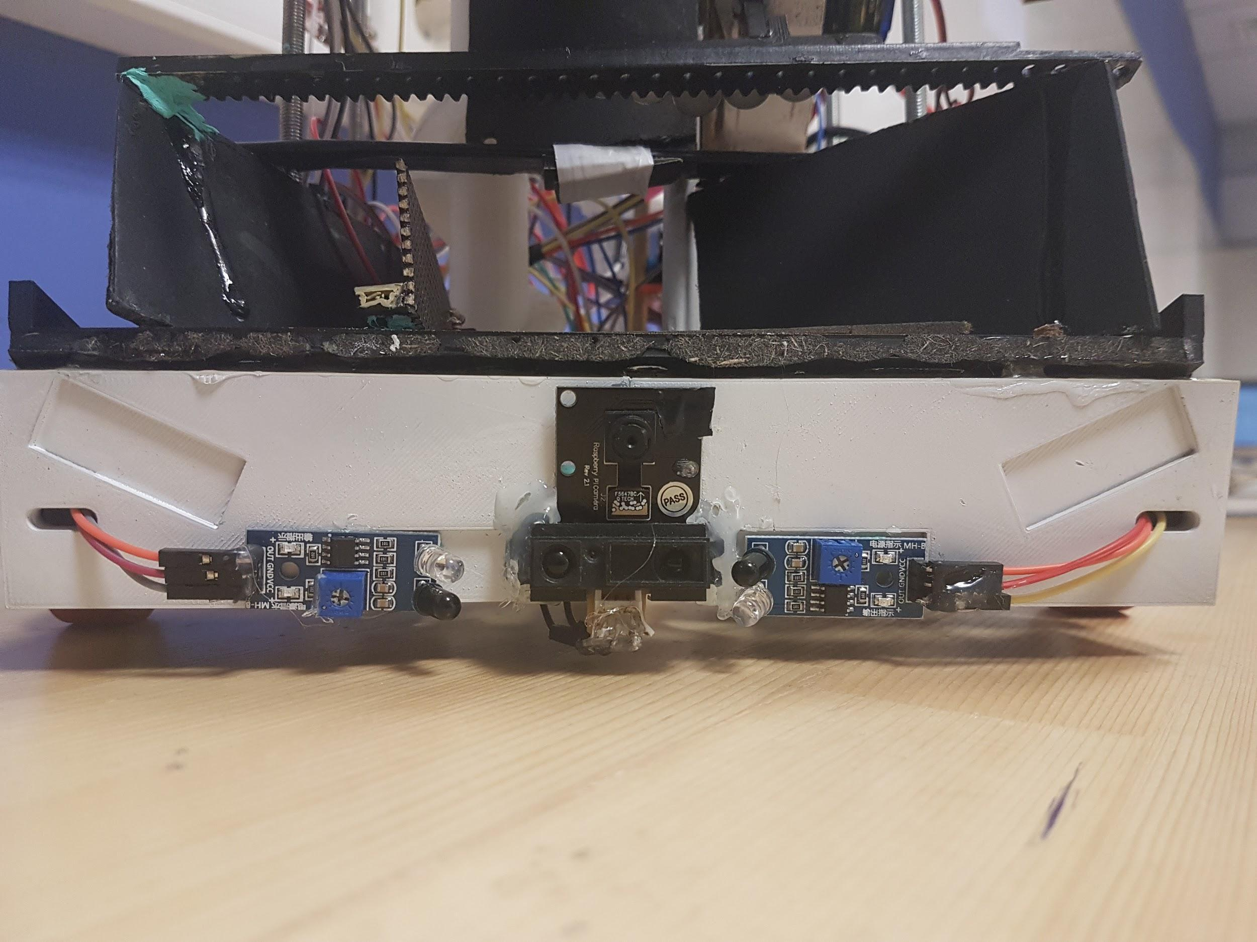

***Figure 4.14: Front sensor placement (Left to right: Infrared sensor, Sharp IR and PI CAM, Infrared sensor)***

##### Motors

In the design of the robot, 4 various motors are used. 2 DC motors for mobility subsystem, 1 DC motor for the lifting mechanism and 1 servo motors for the grab mechanism.

**DC Motor**

22CL-3501PG DC motor is used in the mobility subsystem. Specs of the DC motor of the mobility subsystem is given in the table 4.1

***Table 4.1: Comparison of motors***

|  |  |  |  |  |
| --- | --- | --- | --- | --- |
|  | **Stall Torque** | **RPM** | **Full Load Current** | **No Load Current** |
| 22CL-3501PG | 5 kg/cm | 120 | 0.4A | 0.06A |

The weight of the robot is approximately 2.3 kg and radius of the wheels is 1.5cm which yields that DC motors can move the robot with a weight up to 7.5 kg.

**Servo Motor**

SG90 Servo motor is used to adjust the angle of linear actuator.

In the linear actuator design, servo rotates 180 degrees in either clockwise or counterclockwise direction. Since shaft of the servo is connected to gear system, linear actuator extends to grab the ball and rotates back to its original position.

##### Motor Driver

Since Arduino cannot supply enough current to motors directly and there is need to use H bridge to work in 4 quadrant operations of motor, motor drivers are used. L298N is selected as motor driver. It will be fed from Li-Po battery. Driver has its own 5V voltage regulator and it will be used to feed Arduino Mega.

Current rating of the driver is 2A which is quite sufficient for the operation of DC motors.

##### Power Supply

**LiPo Battery**

One 11,1V Li-Po Battery 2250mAh 25C will be used as power solution. LiPo will be connected to L298N motor driver which has its own 5V voltage regulator and motor driver will feed DC motors together with Arduino Mega.

To maintain security of battery, a buzzer is placed and when SoC of the battery is decreased below critical level, it will warn the members.

**Power Bank**

20.000mAh Power Bank is selected to power Raspberry Pi 3. Power Bank is selected simply because it is convenient. Also, it has the capability of current rating required for Raspberry Pi.

#### Power Management Analysis

Overall power system diagram is given in the figure 4.15

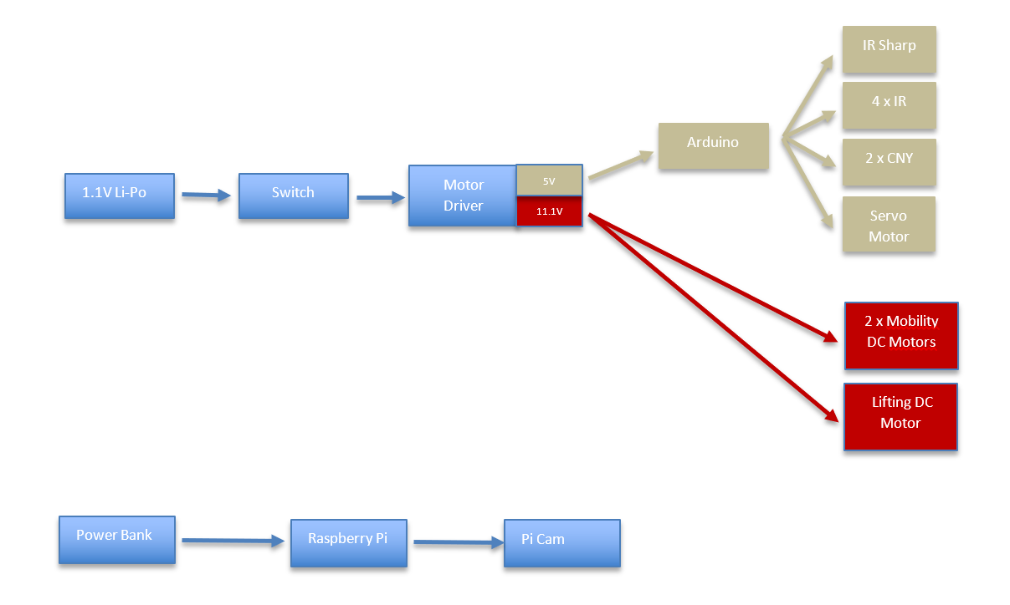

***Figure 4.15: Overall power system diagram.***

As shown in the power system diagram, various sensors are supplied from Arduino. Raspberry Pi is supplied separately from power bank. DC motors are directly supplied by motor drivers which can supply 11.1V.

Furthermore, power consumption of every individual component is one of the major concerns. For this project, components which consume power are listed below according to our measurements separately.

For the Arduino and Raspberry Pi, data is taken while they are on and processing. Also, camera is fed from the raspberry pi, so it is not indicated the list. Similarly, sensors are fed from Arduino and they are not indicated.

***Table 4.2: Power consumption list***

|  |  |  |  |
| --- | --- | --- | --- |
|  | Voltage(V) | Current(mA) | Power(W) |
| DC motors (Mobility) | 12 | 300 | 3.6 |
| DC motor (Lifting) | 12 | 300 | 3.6 |
| Raspberry Pi | 5 | 1200 | 6 |
| Arduino | 5 | 300 | 1,5 |
| Servo motor (Actuator) | 5 | 250 | 1.25 |
| Total |  |  | **15.95** |

According to the table 4.2, instantaneous power consumption is quite low thanks to low current demands of DC motors. Since lifting mechanism does not carry the load but only rotates the shaft, it only demands 300mA.

# **TEST PROCEDURES AND RESULTS**

* **Test results for RAM Screw DC motor:**

Ram Screw is rotating in clockwise direction to raise the ball. This rotation is operated via a standard DC Motor of 5-12 Voltage level and current drawn as 0.1 A No load - 1.6 A Full load.

***Table 5.1: RAM Screw DC MOTOR Lifting time test results***

|  |  |
| --- | --- |
| *DC Motor Voltage(V)* | *Lifting Times (s))* |
| *3* | *9.8* |
| *4* | *6.4* |
| *5* | *4.0* |
| *6* | *3* |
| *7* | *2.6* |
| *8* | *2.3* |
| *9* | *2.0* |
| *10* | *1.6* |
| *11* | *1.0* |
| *12* | *0.9* |

Fastest operation is considered as dangerous for operation since it can cause the ball to drop from screw. therefore, optimal lift time is determined as 1.6 secs and 10 Volts. DC motor power consumption calculation is;

$$P=V×I$$

$$P=12 V×0,6 A$$

$$P=V×I$$

$$P=6,48 W$$

This power consumption level is easily handled by our DC motor and system friction losses are minimized by usage of bearings, so friction losses are negligible.

* **Test results of mobility subsystem:**

According to our test, nominal speed of our robot is 0.4m/s. At nominal speed our robot can go from basket to very end of the baseline within 5 seconds.

Also, in our test robot was able to stop in 1 second from its nominal speed without falling.

* **Test results of microcontroller:**

Communication between Arduino and Raspberry Pi is conducted by serial GPIO connection. In this connection I2C protocol is used. It is seen that with 100kHz clock speed, Raspberry Pi needed about 10ms to send a data packet of 96 bytes.

* **Test results of DC motor of movement:**

Technical specifications of the motor are given in the datasheet below.

* Rated voltage: 12V DC
* Speed (No Load): 120 RPM
* Gear Ratio: 80:1
* Stall Current: 1.8A
* Stall torque: 5 kg-cm

Some tests are conducted to observe the characteristic and precision of the motor. Current that motor draw is recorded and given it the table 5.2.

***Table 5.2: Current ratings of DC motor***

|  |  |  |
| --- | --- | --- |
| *Loading* | *Voltage(V)* | *Current(A)* |
| *No Load* | *12* | *0.06* |
| *Full Load* | *12* | *0.4* |
| *Nominal* | *12* | *0.3* |

The nominal speed of the robot is measured as 0.2 $m/s$ by performing the test. This speed is sufficient for the desired conditions.

* **Test results of sensors:**

**CNY70**

In the datasheet, 0.3 mm distance range is specified. Since balls are physically contact to CNY sensors at the ball verification process, range of the sensor is not considered at all.

**IR obstacle detector sensor 1-2**

IR 1-2 have crucial importance for the ball detection at the ball grab state. Angle of view of the IR sensors is 35 degrees by the datasheet. When tests are conducted, it is decided that 2 IR sensors will be enough to detect balls without error. Horizontal length of the RAM grabber magnetic stick is 5 cm, as shown in the figure, 2 sensors cover all possible locations that RAM grabber can extend.

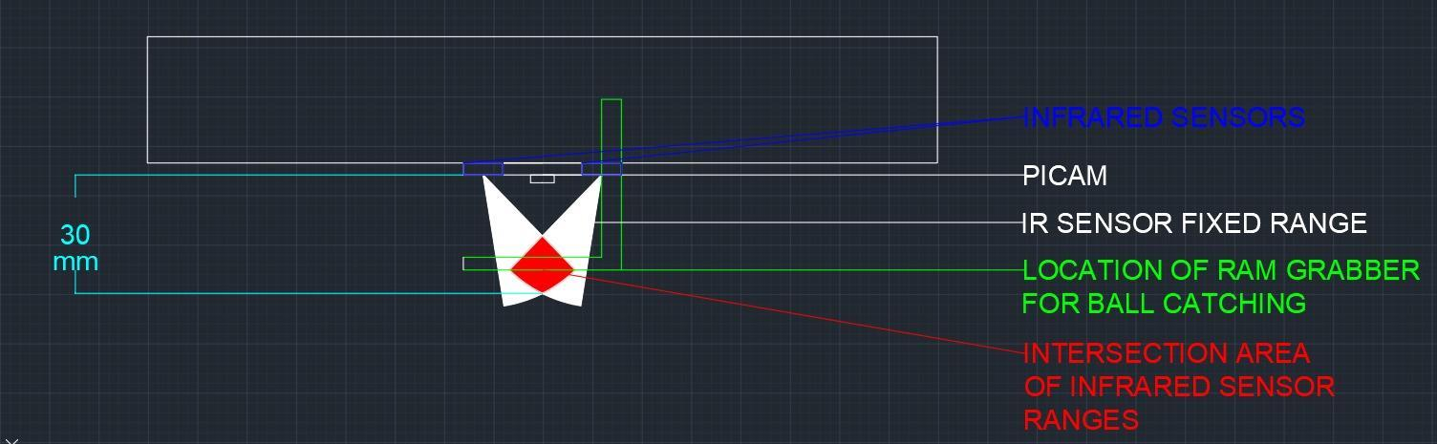

***Figure 5.1: Top view of the front of the robot showing IR sensor ranges and RAM Grabber position***

**IR obstacle detector sensor 3-4**

For the alignment of the robot to basket, 2 IR obstacle sensors are used. When 2 sensors are placed to under the slider, some tests are conducted. Due to thickness of the basket, IR sensors detect basket only when sensor is on the basket with upright angle. At the end of the test, it is observed that error margin of the sensors is 3 mm where maximum error required for the basket is 5mm.

**IR Sharp Sensor**

As described in the datasheet, angle of view of the IR sharp sensor is 7 degrees. Also, its range is defined as 4-30 cm however by practical tests, 4- 25 cm distance range is observed.

Speed of the robot is set to maximum value that sharp IR sensor range will always cover balls. In other words, higher oscillation of the robot due to higher speeds might prevent Sharp IR to detect ball even if robot is closer than 10 cm.

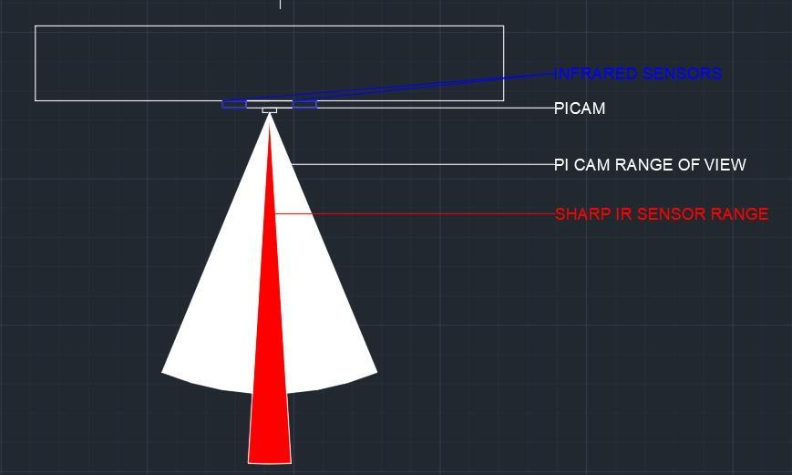

***Figure 5.2: Top view of the front of the robot showing PI CAM and Sharp IR sensor field of views***

* **Test results of servo motor of linear actuator:**

By adjusting servo’s signal input, its shaft rotated 0 $°$ to 180 $°$ and linear actuator extended 16cm. The direction of the movement of the actuator is not parallel to the surface but inclined. 16 cm extension of the actuator yields 4 cm horizontal extension. This amount is reasonable because ball detector sensor ranges are 0-10 cm.

* **Test results of vision & decision subsystem:**

Pixel test is conducted to find the optimum pixel value for the image processed. Latency, the maximum detection distance between the ball and the camera, and frame per second are measured. Results are shown in the table 5.3. According to the results in table 5.3, approximately 400-pixel width of an image will allow the robot to process the image with a desired speed. This performance is enough for our purposes. Frozen frames are observed with a pixel width more than 800px.

***TABLE 5.3: Latency, Detection Distance and FPS of image process***

|  |  |  |  |
| --- | --- | --- | --- |
| **Pixels** | **Latency (s)** | **Max Detecting Distance (cm)** | **FPS** |
| **800,00** | **1,68** | **165,00** | **3,51** |
| **600,00** | **1,30** | **155,00** | **4,6** |
| **400,00** | **0,48** | **110,00** | **7,6** |
| **200,00** | **NA** | **50,00** | **13,58** |

**\*Ball is detected when the radius is greater than 6 pixels.**

# **MODIFICATIONS TO CRITICAL DESIGN REVIEW REPORT**

## 6.1. Image Processing

In the Critical Design Review Report, for detection system we proposed to use pi camera and the images taken from the pi camera is processed so that the ball with a specific color on the playground can be detected. The process of this module is done on Raspberry pi OpenCV python programming language environment. The procedure in this mechanism simply includes converting the image to HSV color space and constructing a mask to the image for desired color (red, blue, green), then detection of circular objects on image by finding their contours, and finally computing the center of the contour and sending the data via I2C communication to Arduino. As RAM, the process of the image is process is not changed; however, the communication between the Arduino and the Raspberry pi is changed from I2C to serial GPIO since it has faster response and less protocol for communication.

## 6.2. Grab, Raise & Drop Subsystem

Operation and design of drop subsystem has been changed at the final version of the robot. Initially, caught ball is raised immediately after the grabbing operation. Then it is placed on to the ball nest at the basket level. then the ball is dropped in to the basket when robot detects the basket via a hatch that was operated with a servo motor.

At the final version of the robot, it no longer has a servo-operated-hatch for drop mechanism; instead it does not raise the ball immediately after grabbing operation. It grabs the ball and keeps the ball at the ground level until it reaches the basket. Raising operation is done after robot is aligned itself with the basket and the ball is dropped into the RAM Slider that slides the ball into the basket.

## 6.3 Sensors

Ultrasonic sensors that were being used for ball and basket proximity measurement are changed into infrared sensors for precision.

# **COMPATIBILITY OF SUBSYSTEMS**

As we explained before, our system is composed of 4 main parts and these systems are grab, rise and drop subsystem, mobility subsystem, vision & detection subsystem and electronics subsystems. Each of those systems were explained in detail. For robot to operate successfully, it is important that these systems need to work together. To do so, these subsystems must have interference with other subsystems. In this part, we are going to explain how these subsystems work with each other.

Before we connect subsystems, subsystems were tested and observed their performances individually. When these operations were applied, some specific observations were noticed such as lifespan of our battery, voltage at motor driver node to supply DC motor and optimum voltage values for our components. After these observations, to obtain more efficient system, some connection has been done in our design.

Camera, which is Pi Cam, was connected to Raspberry Pi with USB. After all these USB connection, to work appropriately and to supply enough current and voltage for all components, Raspberry Pi connected to power bank which provides to 2.1 A to Raspberry Pi because Raspberry Pi needs 5V and 2-2.5 A to work in stable conditions. In this way, vision & detection system was connected with electronic subsystem.

Other components for our system such as motors and sensors are fed by Arduino Mega. Arduino Mega needs to 40 mA for its I/O pins. Connection between Raspberry Pi and Arduino Mega has been done with I2C connection. Arduino Mega is connected to LiPo battery which provides 11.1 V, 2250mAh to the systems. We used different power supplies for our design to make power system more efficient. Also, motors require more currents and LiPo battery can supply these expectations. It is impossible for Arduino Mega to drive motors from its I/o pins. So, to drive DC motors L298N was used. Arduino Mega takes data from sensors and from Raspberry Pi and combines them together to make valuable information. With the implementation of feedback algorithm, Arduino Mega could be able to control DC motors. Also, servo motors that was used in grab lift and drop subsystem was connected to Arduino Mega. By this connection, electronic subsystem was able to communicate with mobility subsystem and grab, lift and drop subsystem.

For better understanding, how the subsystems are interrelated in a high-level fashion, Figure 7.1 shows a signal flow diagram used for our system and Figure 7.2 shows power flow diagram used for our system.

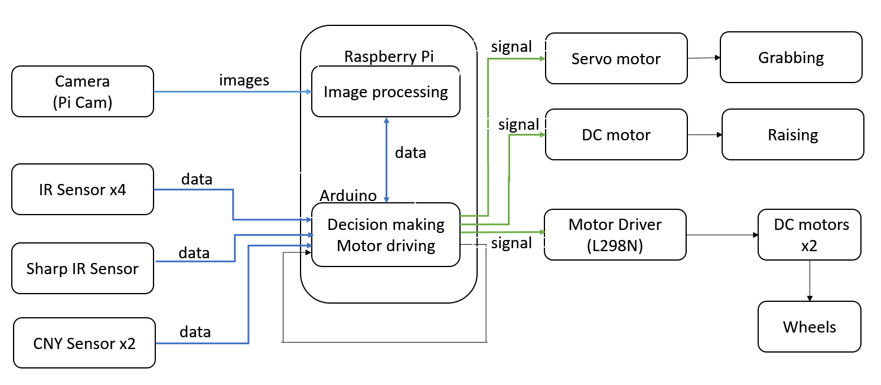

***Figure 7.1: Signal flow diagram***

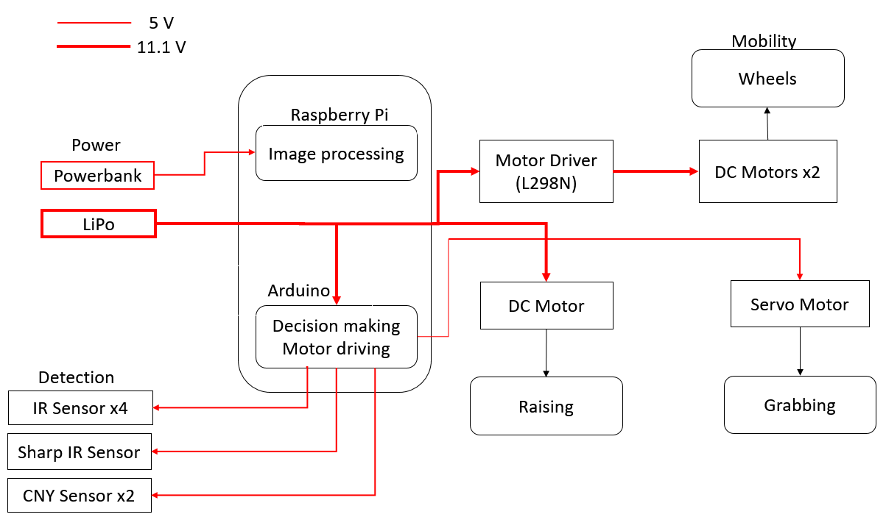

***Figure 7.2: Power flow diagram***

# **REQUIREMENT ANALYSIS**

In order to offer a product which exactly fulfills the requirements, first we need to define what the customer's requirements are. At the end on this process, a couple of requirements that is seen from the view of engineers arises. In this part, both the customer needs and engineering requirements are stated;

**·** In order to exact position, a movement system that runs the robot on a straight line is required. This process can be carried out by DC, step, servo motors. Each motor has advantages and disadvantages. For example, DC motors give high torque, but servo motors are easy to be driven in synchronized.

**·** The position of the ball and the basket should be detected. In order to fulfill this requirement, an ultrasonic sensor, IR sensor, and camera can be used. Advantage of the sensor is that data obtained from it can be easily processed. However, its signal may not be reflected on some situations. For camera, image processing is harder than sensor, also it may get affected from sunlight or some other lights but with the proper filtering, the camera can fulfill detection requirement.

**·** Our robot must decide whether moving or not is better in order to capture the ball. Therefore, appropriate decision algorithm should be provided. For this purpose, using angular position and distance of the ball with respect to the robot which are obtained from image processing and sensors to make right decision.

## 8.1. Obtained Performance

Detection mechanism is applied with image processing with the help of the ping pong ball.

**·** Connection between Raspberry Pi and Arduino MEGA was performed. This is essential for us since information from the camera is evaluated by Raspberry Pi and movement is applied by Arduino Mega. This connection is conformed via GPIO connection and information was transferred from Raspberry Pi to Arduino Mega successfully.

**·** Mechanical implementation was completed. In mechanical design, main chassis were constructed to use area at optimum level for our components.

**·**  Lifting mechanism was tested with the ping pong ball and our design, RAM Screw, could be able to lift the ball in 2 second.

Besides these performances, although speed is not a main criterion for this project, RAM  
tries to do its best in this regard.

### PROJECT MANAGEMENT

## Team Organization

**Uğur Can YILMAZ -** Research on image processing and communication, implementing mechanical systems, research on control of DC motor and simulations on electrical systems.

**Bekir Caner YAĞCI –** Responsible for research and implementation of image processing & decision unit. Also responsible for mechanical solutions.

**Burak BOZ –** Responsible for maintaining moving parts’ movability and keeping fixed parts rigid. Also, research on infrared and ultrasonic sensors and implementation of electrical components (Sensors, Arduino, Motors), calibration of sensors, material selection.

**Onur Erkin SUCU -** Responsible for research and implementation of feedback & mobility unit, implementing mechanical systems, selection and implementation of sensors.

**Deniz Sedar SUNA -** Research on mechanical solutions and possible alternatives for grab, raise & drop operations. Responsible for mechanical applications and assemblies. Also responsible for CAD drawings and mechanism tests.

***Table 9.1 : Table for representing division of work***

|  |  |  |  |  |  |
| --- | --- | --- | --- | --- | --- |
| **SUBSYSTEMS/NAMES** | Bekir Caner Yağcı | Deniz Sedar Suna | Burak Boz | Onur Erkin Sucu | Uğur Can YILMAZ |
| MOVEMENT | + | + |  | + | + |
| VISION AND DECISION | + |  | + |  | + |
| GRAB,RAISE & DROP MECHANISM | + | + |  |  |  |
| CONTROL |  |  |  | + | + |

## Budget and Deliverables

**Actual Expenditures**

Final product includes the components in table 9.2.

***Table 9.2: Actual expenditures of the system***

|  |  |  |
| --- | --- | --- |
| Component | Number of Components | Price ($) |
| Arduino Mega R3 Clon | 1 | 10 |
| Raspberry Pi 3 | 1 | 37.4 |
| Pi Cam (D) | 1 | 16.95 |
| 16 GB SD Card | 1 | 4.7 |
| 22CL-3501PG DC Motor | 2 | 21.4 |
| DC Motor | 1 | 7.14 |
| L298N Motor Driver | 2 | 6.4 |
| CNY70 Sensor | 2 | 2 |
| SG90 Servo Motor | 1 | 2 |
| Li-Po Battery | 1 | 18.2 |
| Power Bank | 1 | 10 |
| 3D Printed Pieces* | 175 grams | 16.6 |
| FC-51 IR Sensor | 4 | 4 |
| IR Sharp Sensor | 1 | 7 |
| Wheels | 2 | 4.8 |
| Ball Caster Wheel | 1 | 2.8 |
| Ping Pong Balls | 6 | 1 |
| Hardware Components | - | 8 |
| Various Jumper Cables | - | 2 |
|  | Total | **187.39** |

*\*The price of the 3D printed pieces is 0.10$ per gram.*

Additional 10 dollars of expenditure is spent on infrastructure materials such as silicon gun, nipper, RGB paints, etc.

With the additional cost, total money spent on the project is 197.39 dollars.

**Deliverables:**

As RAM Company, following equipment will be delivered to the customers:

**-Robot**: A robot takes part in a basketball shootout will be delivered. The robot will be consisted of control cards, PICAM, lifting system and movement system. Software program will be provided to control the robot.

**-Basketball Court:** A board that the robot will perform on it will be delivered.

**-Basket:** A basket manufactured from a pipe will also be delivered.

**-Manual:** User manual will be provided to clients.

# **CONCLUSION**

Regarding the safety issues an alarm buzzer is connected to the Li-Po battery to warn the user when it is at critical values. Also, a main switch which disconnects the whole system from the Li-Po battery is implemented on the system which can be used in dangerous situations.

The product can be a good example for the robotic projects where image process, motor driving and object picking are take place.

Environmental impacts of the robot are considered while instrumenting. Most of the mechanical parts are printed in 3D printer where eco-friendly materials can be used to build these parts.

# **REFERENCES**

[1]<https://www.youtube.com/watch?v=2iSRE6rGGLE> (RAM Screw Design)

[2]<https://www.pyimagesearch.com/2015/09/14/ball-tracking-with-opencv/> (Ball Tracking)

[3]<https://www.pyimagesearch.com/2014/07/21/detecting-circles-images-using-opencv-hough-circles/> (Circle Detection)

[4]<http://www.st.com/content/ccc/resource/technical/document/datasheet/82/cc/3f/39/0a/29/4d/f0/CD00000240.pdf/files/CD00000240.pdf/jcr:content/translations/en.CD00000240.pdf> (Motor Driver)

[5]h[ttps://www.robotistan.com/1001-arkadan-mil-cikisli-12v-320rpm-karbon-fircali-mikro-metal-dc-motor-pl-3052](https://www.robotistan.com/1001-arkadan-mil-cikisli-12v-320rpm-karbon-fircali-mikro-metal-dc-motor-pl-3052) (DC motor)

# **APPENDIX A: USER MANUAL**

**ABOUT RAM:**

|  |  |
| --- | --- |
| **Suitable Age:** | 6+ Years |
| **Power Supply:** | 3 cell LiPo (11.1 Volt 2000mAh)  Power Bank (20000mAh) |
| **Weight Capacity:** | Can carry up to 2.5 kg |
| **Maximum Speed Limit:** | $$0.2 m/s$$ |

**BOX INCLUDES:**

|  |  |
| --- | --- |
| **RAM Robot** | **6 Ping Pong Balls** |
| **Li-Po Battery** | **Basket** |
| **Power Bank** | **Basketball court** |
| **Li-Po Charger** | **Li-Po Buzzer** |

**NOTICE**: While the RAM is activated, buzzer should be connected to the battery in order to avoid any malfunctions that can occur due to critic voltage levels.

**WARNING:** While the RAM is activated, any external intervention may be harmful.